Student’s name | …………………………………………………….…… | Grade | 4
Subject | Computer | Week No. | 3
Lesson Title | Network Connections | Unit
Worksheet No. ( 3 ) (Answer)

write the correct name of each part.
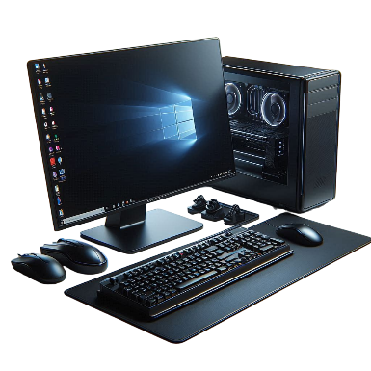
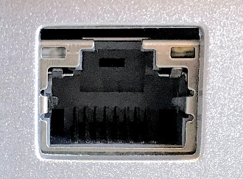
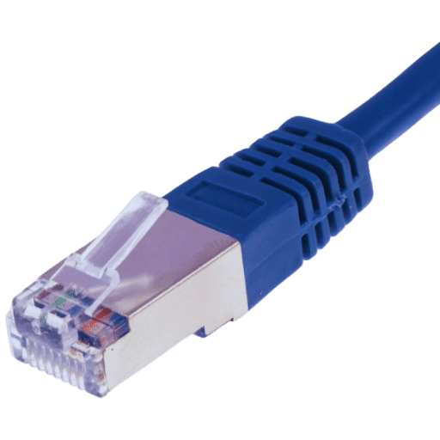

Good Luck

Laptop
Ethernet Port
Ethernet Cable
CPU
Ethernet Port
Ethernet Cable
Laptop
CPU

